Coursework

abiye100.pythonanywhere.com

Web Forms

My application uses Web forms for the users to enter data into the application. The Data that the user can enter is a username, email address and password which needs to be confirmed. The webform uses appropriate data types for storing this information into the database model named social.db. The web forms as well use validation to ensure that the correct data is being entered through. The Username must be unique and so does the email. The max length assigned for a password is 100 characters.

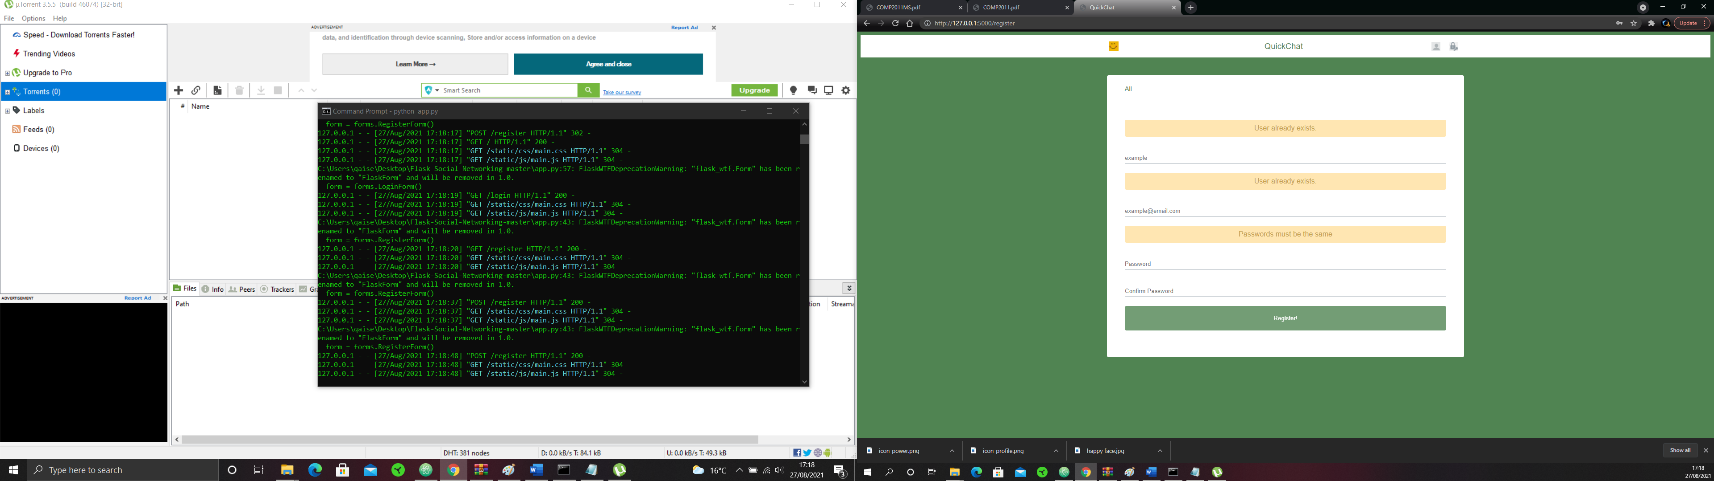

Database

My database contains three tables. The three tables refer to user posts, relationships between users. Because these tables relate to each other I have set primary and foreign keys in the database to allow for a many to many relationships between these tables. The database uses validation to only allow for unique data fields, character limits and not null fields where data must be entered.

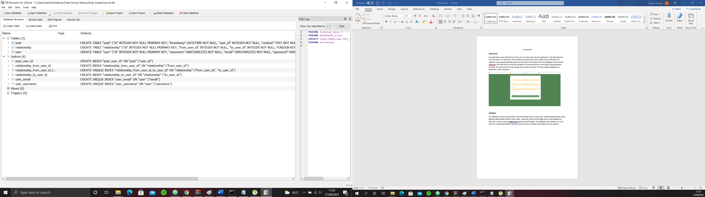

Database visualisation tool not used to create database

Authentication and Sessions

My application allows for users to log into their own portal giving them access to write a new post and to follow and unfollow other users. Currently there isn’t functionality for a user who wishes to change their password as I didn’t have enough time however from my research, I have determined that I would have a new route to a change password page. From there I would have three data fields. One to confirm the current password and two for changing the password to a new password again using two to confirm that is the correct password they have typed in. From this point I will use SQLite Database to check if the current password matches their password stored in the database and if it does then to update the password field to their new password given that they have entered the same password in twice.

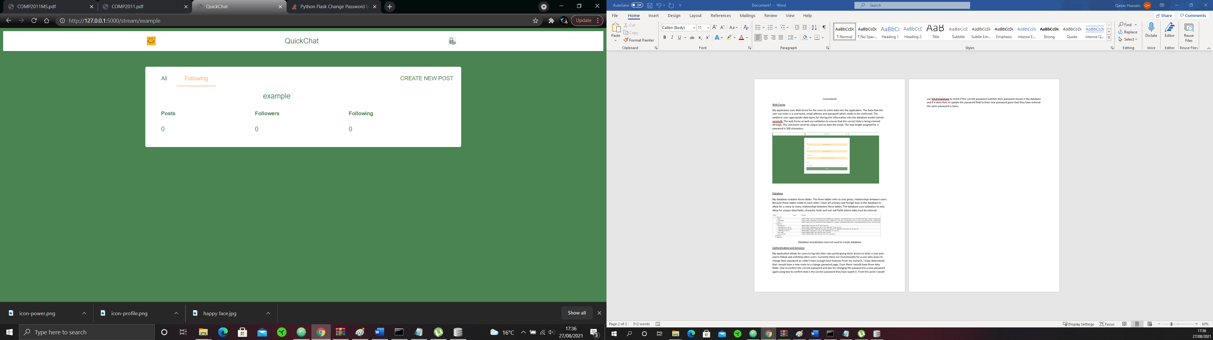

Appropriate Styling

The styling choices that I have made are inspired by my research on web pages. I have found headers at the top of the page like this design to be aesthetically pleasing and have chosen colours I believe compliment well with the design. I have chosen a soft green colour for the background and the text as I wanted them to be consistent across the application. With more time I would have preferred to design my own logos as using copyright free pictures takes away from the professional look I was going for and doesn’t correspond to my otherwise consistent design scheme. All my designs have been done in CSS and with more time I would have wanted to develop my knowledge in CSS as I have stated I would for Flask.

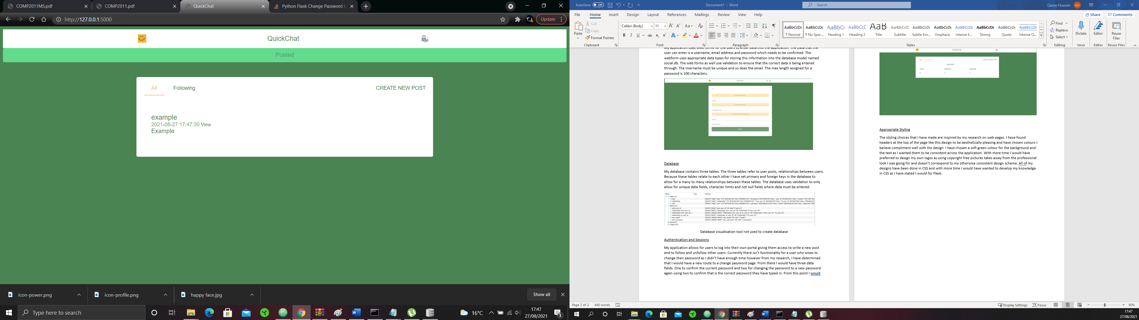

Features

For my choice of feature, I have used JavaScript however only for basic functionality. I have used the script to preload any images. This is done to ensure that my application is made aware that these images are essential and that they should be loaded before the html script. This will avoid any loading issues with my images if I were to expand the application. With more time I would have enjoyed implementing more JavaScript into the application especially introducing changing bodies of text for users who would take an interest into learning more about my social media.

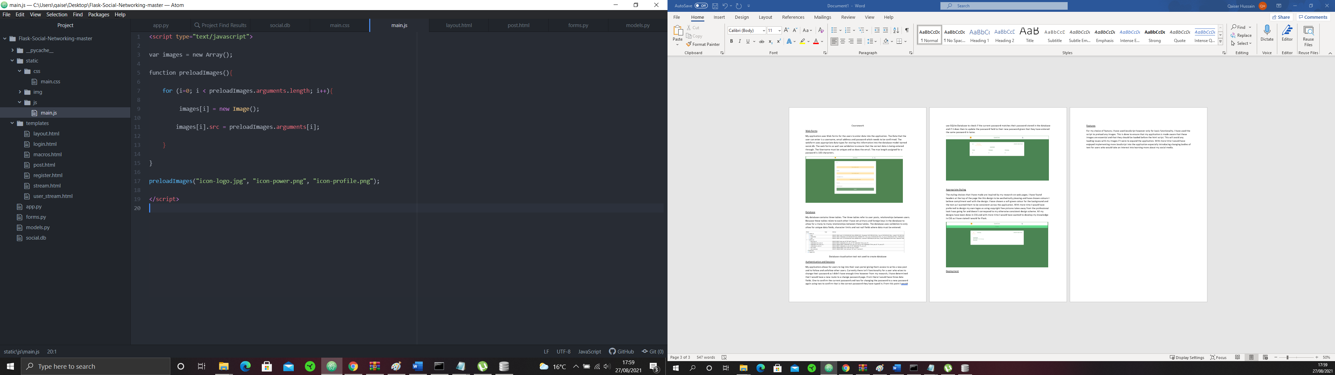

Conclusion

Working with the technologies flask, html, javascript and css have been a great learning oppournity and I am intriged to continue my knowledge on these technologies. I have utilised flask in a way that I feel is efficent and managable. With more time and development I would have liked to expand my application to add features such as private messaging, changing password and setting profile pictures. However with the application and end result I have achived I am pleased and will continue to expand my knowledge in this area.